
Thames Valley Animal Welfare
Calendar & Christmas Card Order Form
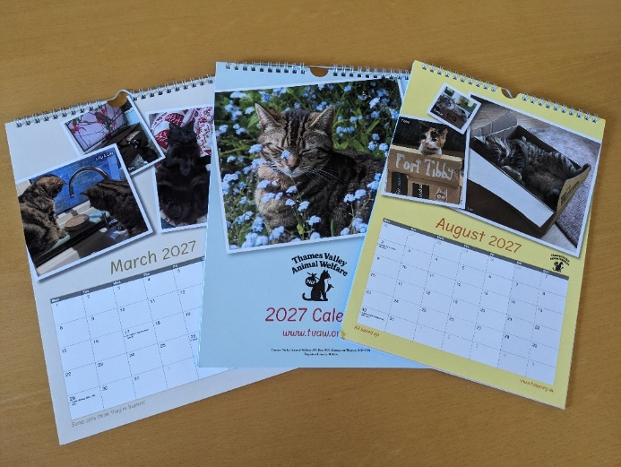

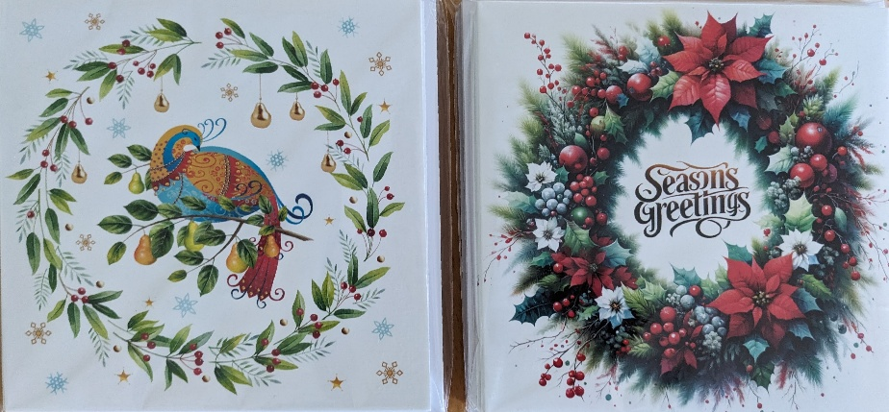
Registered charity 900616
2027 Calendars
Packs of 10 cards with envelopes

Name:
Address:

Postcode: Phone number *:
* Just in case we need to get hold of you.
 | Number of calendars @ £12 each | Packs of cards @ £5 each | Total cost
2027 Calendars
Partridge Christmas cards
Wreath Christmas cards
Post & packing | £2.50 for up to 3 calendars | £2.50 for up to 5 packs
Extra donation
Total

To order, please complete this form and email it to newsletter@tvaw.org.uk. You can pay online to CAF Bank, account number 00008313, sort code 405240. Please put your name and ‘Calendar’ as the reference.
Or you can post this form to Chantal Cornelius, Appletree Cottage, Coombe Road, Compton, Berkshire, RG20 6RQ along with a cheque, made out to Thames Valley Animal Welfare.
Gift Aid declaration: Please tick here if you want to Gift Aid your donation.
I want to Gift Aid my donation to TVAW. I am a UK tax payer and understand that if I pay less Income Tax and/or Capital Gains Tax than the amount claimed on all my donations in that tax year it is my responsibility to pay any difference.
Thames Valley Animal Welfare, PO Box 4931, Henley-on-Thames, RG9 9NB
Thames Valley Animal Welfare
Calendar & Christmas Card Order Form

Registered charity 900616
2027 Calendars
Packs of 10 cards with envelopes

Name:
Address:

Postcode: Phone number *:
* Just in case we need to get hold of you.
 | Number of calendars @ £12 each | Packs of cards @ £5 each | Total cost
2027 Calendars
Partridge Christmas cards
Wreath Christmas cards
Post & packing | £2.50 for up to 3 calendars | £2.50 for up to 5 packs
Extra donation
Total

To order, please complete this form and email it to newsletter@tvaw.org.uk. You can pay online to CAF Bank, account number 00008313, sort code 405240. Please put your name and ‘Calendar’ as the reference.
Or you can post this form to Chantal Cornelius, Appletree Cottage, Coombe Road, Compton, Berkshire, RG20 6RQ along with a cheque, made out to Thames Valley Animal Welfare.
Gift Aid declaration: Please tick here if you want to Gift Aid your donation.
I want to Gift Aid my donation to TVAW. I am a UK tax payer and understand that if I pay less Income Tax and/or Capital Gains Tax than the amount claimed on all my donations in that tax year it is my responsibility to pay any difference.
Thames Valley Animal Welfare, PO Box 4931, Henley-on-Thames, RG9 9NB

